

**PROJECT**

**Order a Drink App With Sqlite**

**Group 10**

Names :

1. Muhammad Ryan Cakranigrat

Class : 4 ISA 3

Faculty :

Mhd Idham Khalif, S.Kom

**CEP CCIT**

**FAKULTAS TEKNIK UNIVERSITAS INDONESIA**

**2023**

**PROJECT ON**

Order a Drink App With Sqlite

**Developed by :**

* **Muhammad Ryan Cakraningrat**



**Order a Drink App With Sqlite**

Batch Code : 4 ISA 3

Start Date : Friday, 12 Mei 2023  
End Date : Friday, 18 April 2023

Name of Faculty : Mhd Idham Khalif, S.Kom

Names of Developer :

1. Muhammad Ryan Cakraningrat

Date of Submission :



**CERTIFICATE**

This is to certify that this report titled ”**Order a Drink App with Sqlite**” embodies the original work done by Muhammad Ryan Cakraningrat. Project in partial fulfillment of their course requirement at NIIT.

Coordinator:

Mhd Idham Khalif, S.Kom

\

\

**ACKNOWLEDGEMENT**



Thank you, the writer wishes to God the Almighty for His blessings, we can complete this Project about Object Oriented Programming entitled “Order a Drink App With Sqlite” for Friendly task both in the form of presentation and paper in a timely manner. Thank you especially for Mhd Idham Khalif, S.Kom and another faculty who always help. Thank you also to fellow students who have supported, and also thank you for being fellow workers in the education at CCIT-FTUI.

The author realizes that in the preparation of this project there are still many shortcomings and far from perfection. Therefore, the authors expect constructive criticism and suggestion to improve this paper and can be a reference in preparing the papers or subsequent tasks.

Depok, April 2023

Author

\

**System Summary**

**System Summary :**

This Drink Order Application Program uses an SQLite Database to store user data, including Registration/Login Information and Orders made by users. A wide variety of Drinks from countries including Italy, Spain and Japan are available in this app. The customer can choose the right Drink for him before placing his order in the basket, which can be removed if there is a matching order. After selecting payment the user can click the confirmation button to then be able to complete the transaction.

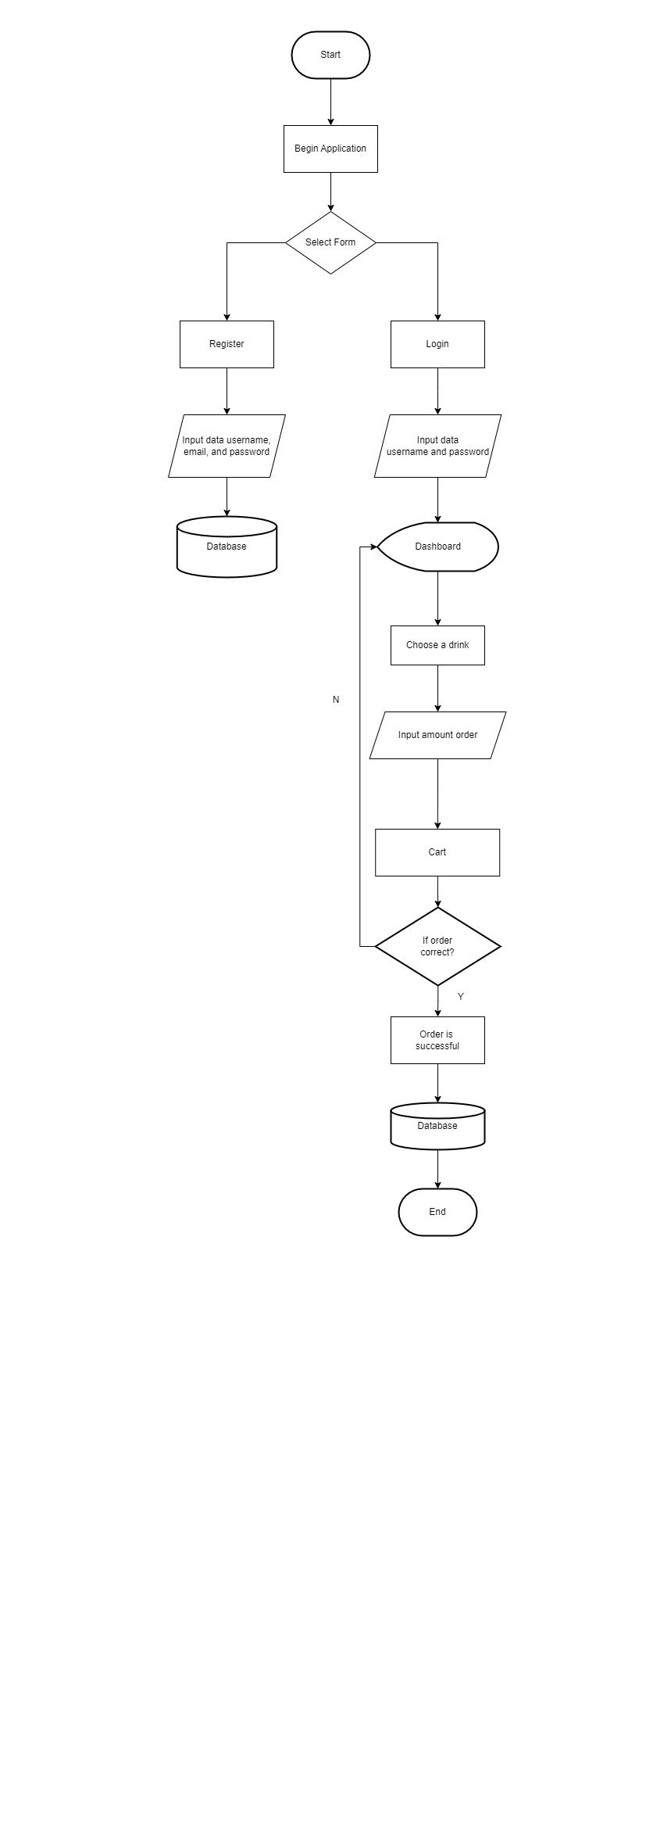

**FLOWCHART**

**IDLE**

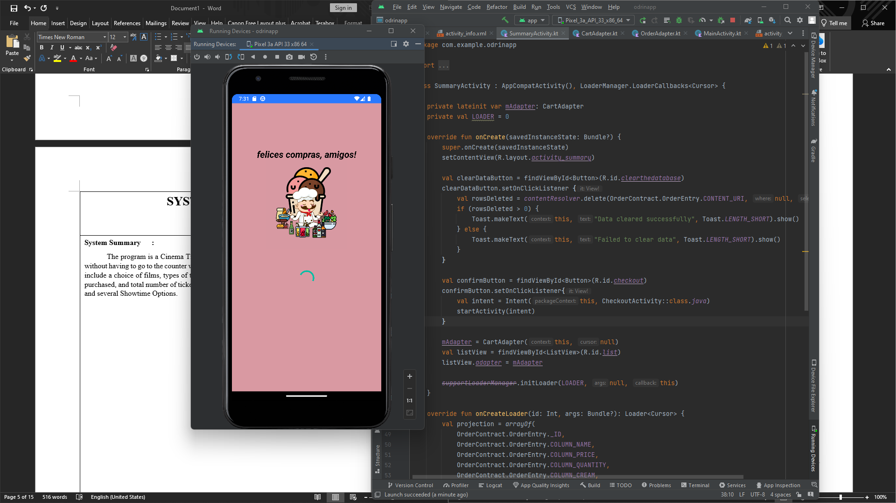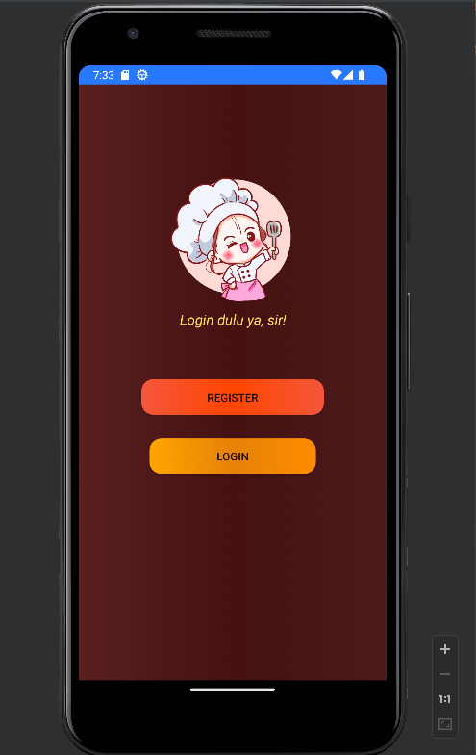

Figure 1. loading screen dan welcome

After running the code, a loading screen will appear like this then proceed to welcomeActivity which is the initial display while heading to the application

**OUTPUT PROGRAM**

**Input User data and Sign In**

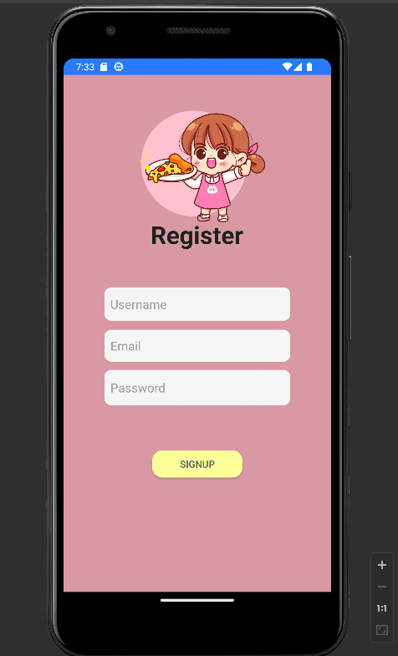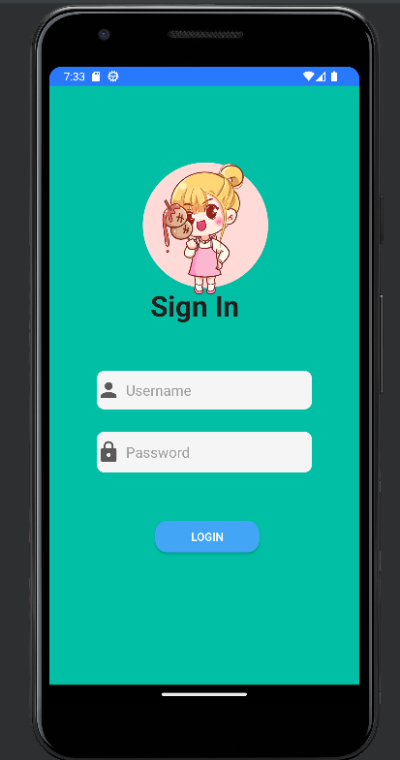

If we have already registered for an account, we don’t need to do it again, but if not we must first fill it out

**Choose a type of Drink**

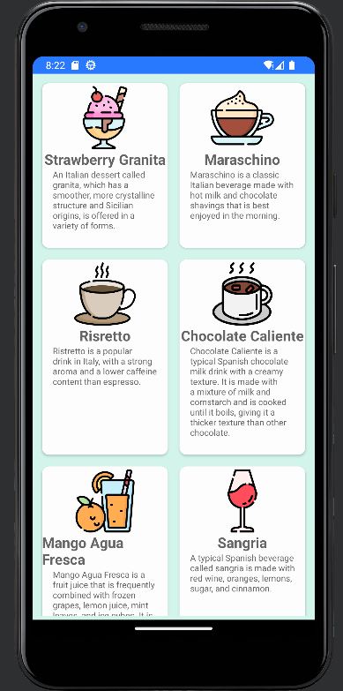

After Successfully logging in, we can immediately choose the available drinks

**Info each drink**

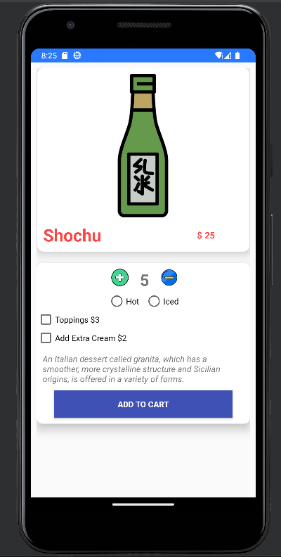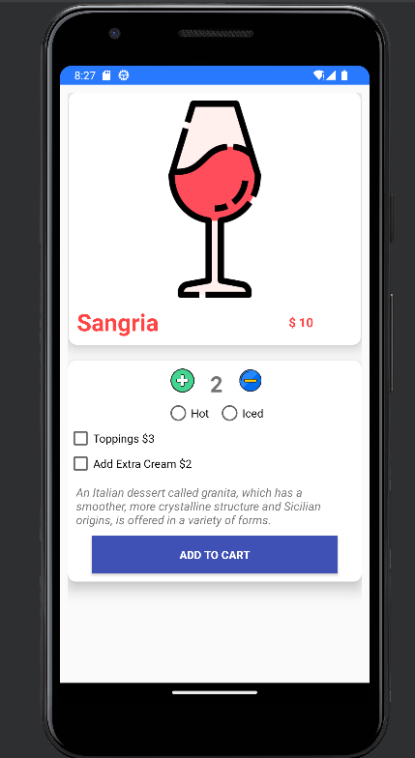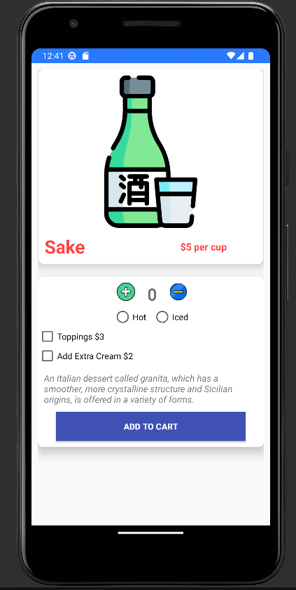

After we choose the various type of drinks we can choose how much to order and also the various extras available.

**Order Basket**

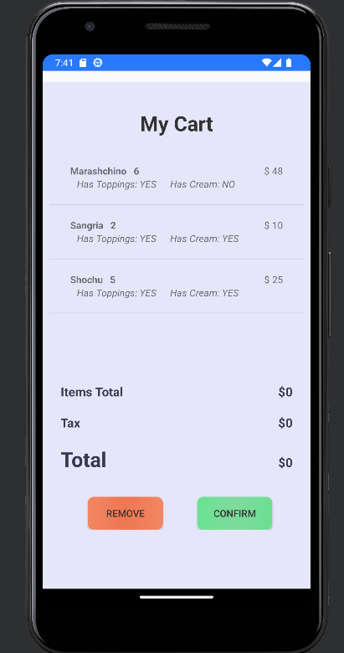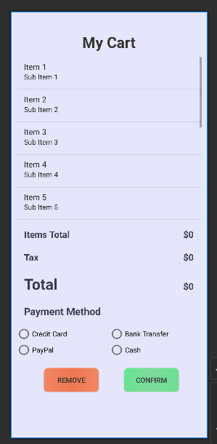

Every menu that the user choose will appear in this activity then if the user has an error in entering data, you can use the remove button to delete the order and if its correct you can press confirm to continue payment.

**Hardware : PC**

**Operating System : Windows 11**

**Software : Android Studio, Draw.io, Microsoft Power Point, Microsoft Word**

|  |  |  |
| --- | --- | --- |
| **PROJECT FILE DETAILS** | | |
| **No** | **File Name** | **Remarks** |
| 1 | OdrinkApp_Group14.rar | Kotlin Program |
| 2 | OdrinkApp_Group14.docx | Word document |
| 3 | OdrinkApp_Group14.pptx | PowerPoint file |
| 4 |  |  |

**CONFIGURATION**

**Hardware :**

**Operating System :**

**Software :**

|  |  |  |
| --- | --- | --- |
| **PROJECT FILE DETAILS** | | |
| **S.No** | **File Name** | **Remarks** |
| 1 | Snake.cpp |  |

**CONFIGURATION**